**Main Method**

**Whether the class contains main() method or not,**

**and whether it is properly declared or not,**

**these checking's are not responsibilities of the compiler, at runtime JVM is responsible**

**for this.**

**If JVM unable to find the required main() method then we will get runtime exception**

**saying NoSuchMethodError: main.**

Example:

class Test

{}

Output:

javac Test.java

java Test R.E: NoSuchMethodError: main

At runtime JVM always searches for the main() method with the following prototype.

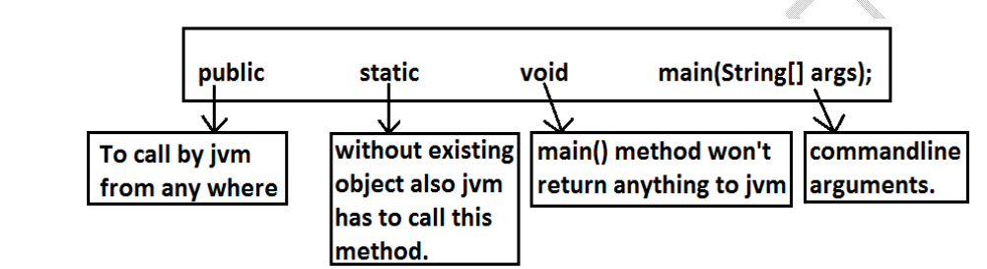

**If we are performing any changes to the above syntax then the code won't run and will**

**get Runtime exception saying NoSuchMethodError.**

**Even though above syntax is very strict but the following changes are acceptable to**

**main() method.**

**1. The order of modifiers is not important that is instead of public static we can**

**take static public.**

**2. We can declare string[] in any acceptable form**

**o String[] args**

**o String []args**

**o String args[]**

**3. Instead of args we can use any valid java identifier.**

**4. We can replace string[] with var-arg parameter.**

**Example: main(String... args)**

**5. main() method can be declared with the following modifiers.**

**final, synchronized, strictfp.**

**6. class Test {**

**7. static final syncronized strictfp public void main(String... ask){**

**8. System.out.println("valid main method");**

**9. }**

**10. }**

**11. output :**

**12. valid main method**

**Case 1 :**

**Overloading of the main() method is possible but JVM always calls string[] argument**

**main() method only.**

**Example:**

**class Test**

**{**

**public static void main(String[] args)**

**{**

**System.out.println("String[] array main method"); //overloaded**

**methods**

**}**

**public static void main(int[] args)**

**{**

**System.out.println("int[] array main method");**

**}**

**}**

**Output:**

**String[] array main method**

**The other overloaded method we have to call explicitly then only it will be executed.**

**Case 2:**

**Inheritance concept is applicable for static methods including main() method**

**hence while executing child class if the child class doesn't contain main() method then**

**the parent class main() method will be executed.**

Example 1:

class Parent

{

public static void main(String[] args)

{

System.out.println("parent main"); //Parent.java

}

}

class Child extends Parent

{}